ME540 Homework Week 8 Andrew Alferman, Zoe Lavrich

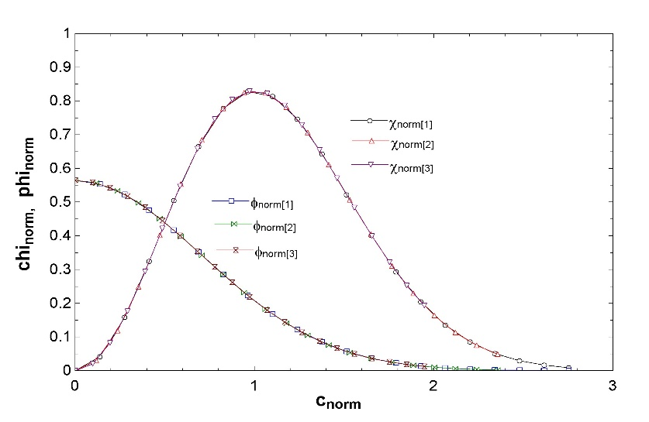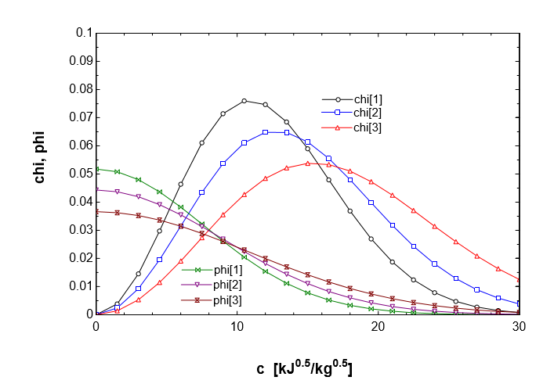Homework for week 8 focused on Kinetic Theory of gases. First a dimensionalized version of the distribution Φ for nitrogen gas (N2) at temperatures of 200, 273 and 400 [K] as shown in Figure 1 was plotted based on the equations below, in which m is the particle mass and T is the temperature in Kelvin:

Figure . nondimensionalized distribution for Nitrogen at 1)200K, 2)273K and 3)400K

Figure 1. dimensionalized distribution for Nitrogen at 1)200K, 2)273 K, and 3)400K





The most probable speed of 402.6 m/s, average speed of 454.2 m/s and root-mean-squared speed of 493 m/s of the Nitrogen molecules at 273K were then calculated based on the following equations:



Figure 3. Collision frequency of oxygen.





Figure 8 from page 45 of Vincenti and Kurger was then recreated as shown in Figure 2 using the equations below:







The collision rate of oxygen gas (O2) with nitrogen gas (N2) in air at a total pressure of 1 atm and a temperature of 0°C was determined to be 4.397E+33 Hz/m3 based on the equation:



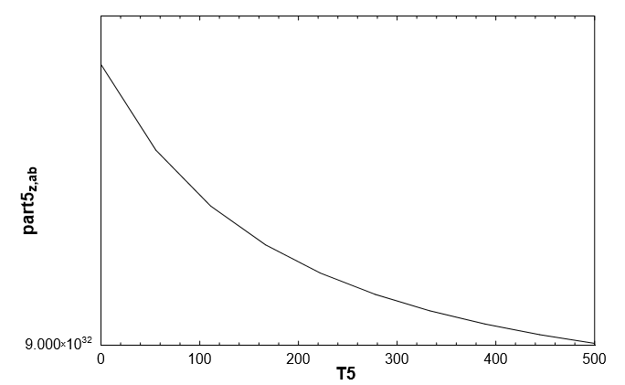As figure 3 shows, the collision frequency for oxygen decreases as temperature is increased.

The mean free path of the oxygen molecules of 4.648E-07 m was calculated using the simplified equation:

